[1]

ToDoList

Assignment 2

Kwangkyu Choi

This project is about building a scheduling application. In this project we need to deal with interacting two activities, contentprovider, broadcast receiver for the application.

# INTRODUCTION

I learned how android studio structured and how each element interacts each other such as one activity to another activity, storing and retrieving information using contentprovider. Plus, broadcast receiver to interact with system and application.

# Application Design

I mainly used intent object to pass information from one activity to another activity. I used startActivityforResult function to send intent object and receive extra information from second activity. I could have used startActivity function just send intent object to second activity and no need to respond back from second activity.

I used given contentprovider to interact with application internal database. Given contentprovider is a extend version of default contentprovider. I used query function to create new records and delete old records. I used update function to update existing records to current status.

I used datepicker timepicker function for user to select the date information instead of getting it typed.

# Results

My application is working for number 1 through number 6 and partially number 7. I was trying to make number 7 work for certain time but failed. User can create, read, update, delete most of the information using two activities. I believe there are no errors and malfunctions for each step out of what I have implemented.

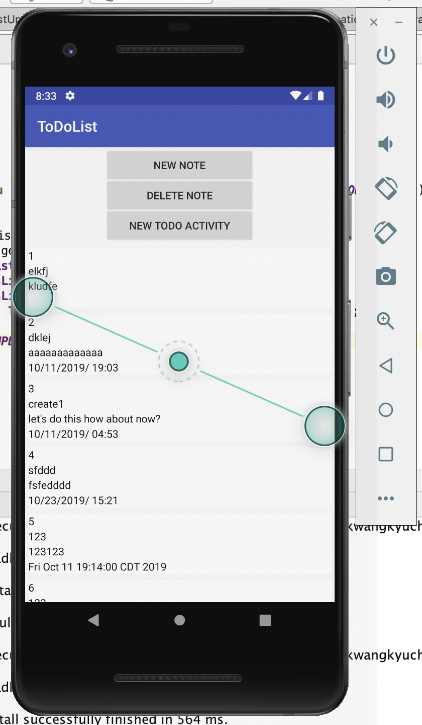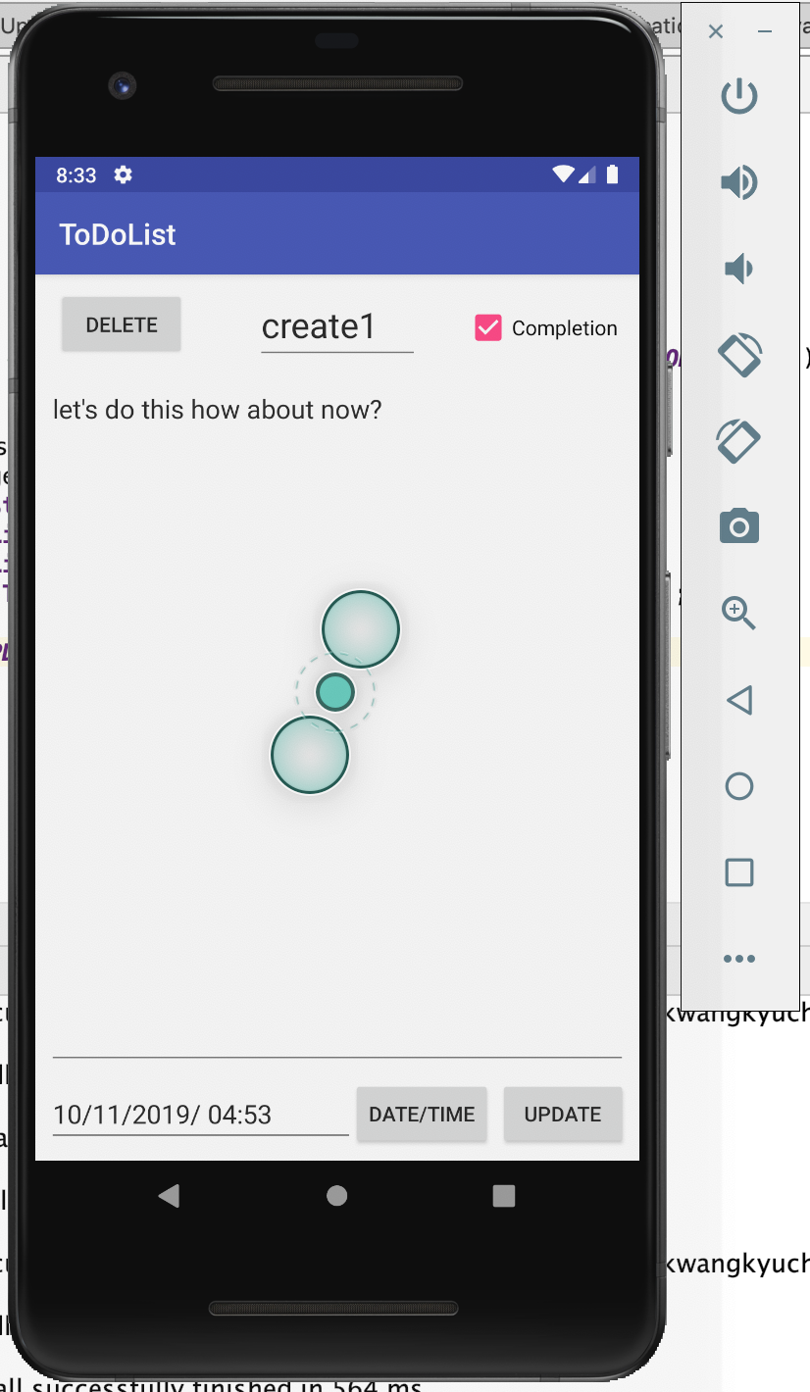

References

1. “Coding in Flow.” *YouTube*, YouTube, www.youtube.com/channel/UC_Fh8kvtkVPkeihBs42jGcA.

1.